Circle Labs

Install guide for the smart medical management system

Contents

Prerequisites 1

Adding the database user 2

Setting up the database 4

Setting up the site 4

# Prerequisites

* XAMPP 7.4.4 is installed locally.
* A copy of the Smart Medical Management Software.

# Adding the database user

1. Start the XAMPP server and start the apache and MySQL services.
2. Open your web browser and go to localhost
3. Then click phpMyAdmin in the top right-hand corner
4. Click databases at the top
5. Then click user accounts
6. Then click add user account. You will then see a screen like this.

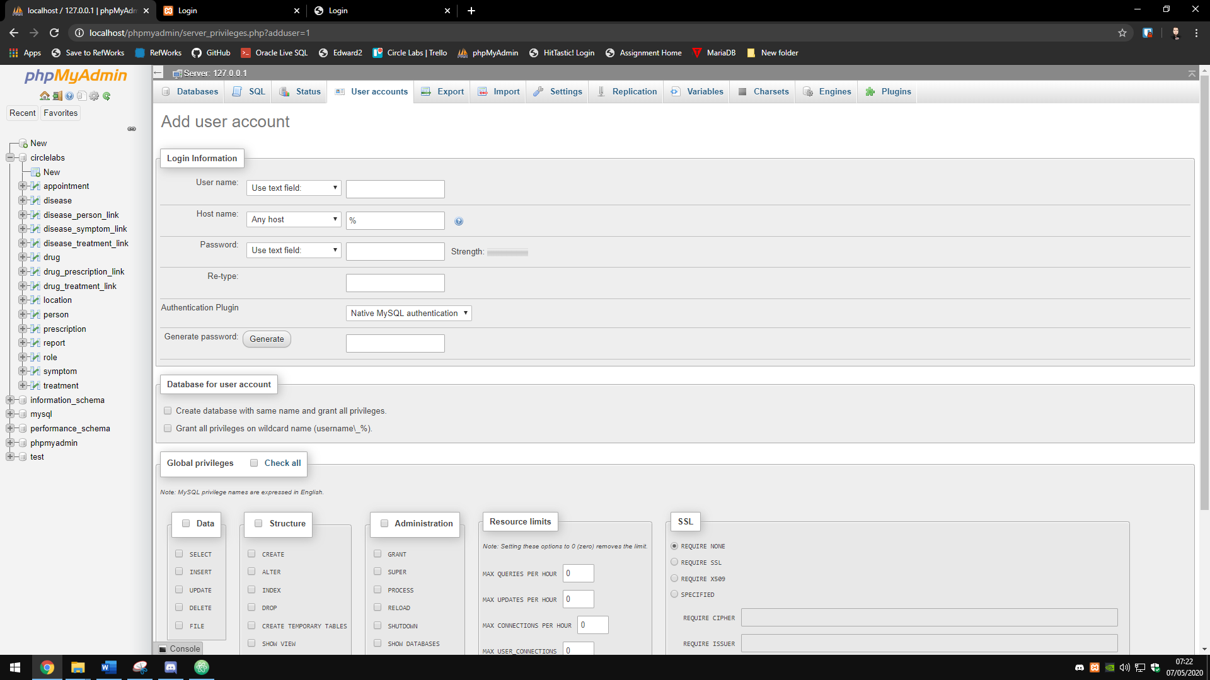

1. Put this in username CircleLabs
2. Put this in both password boxes Yf25&ZPPaAAk
3. Then check the global privileges box is ticked. It should then look like this.

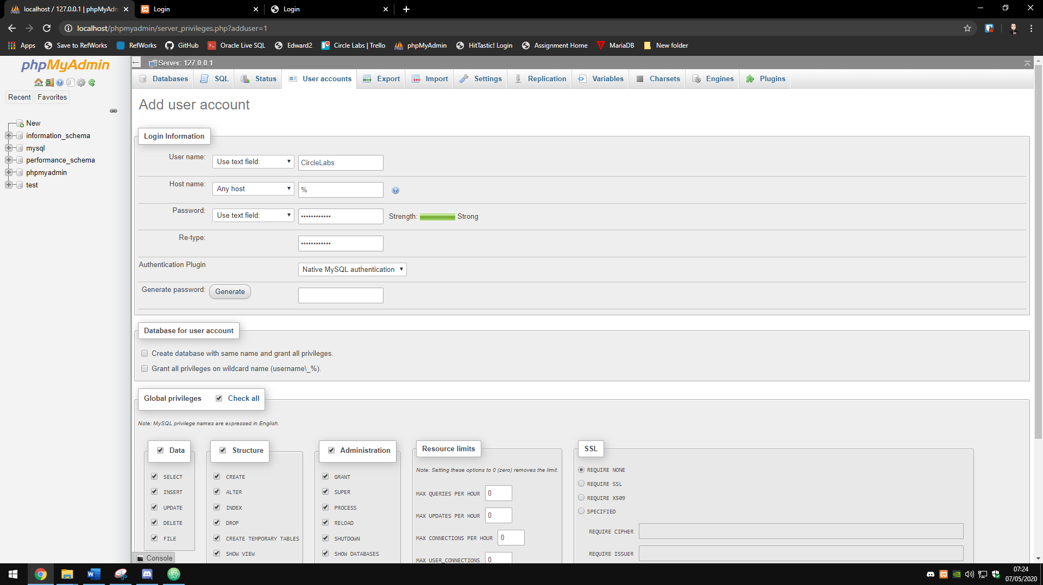

1. Then scroll down to the bottom and press go in the right-hand corner. You should see this message.

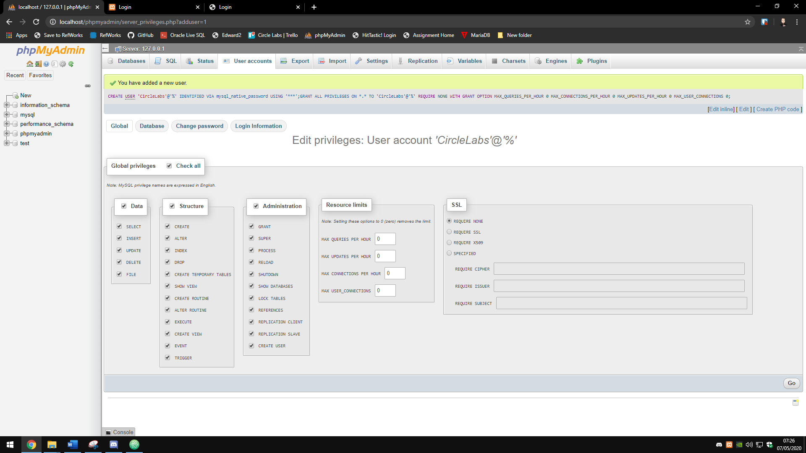

1. Finally click user accounts and you should see CircleLabs listed.

# Setting up the database

1. Then click on databases
2. Then click on import
3. Click choose file and then navigate to the Base DB SQL script in the installation folder.
4. Then click go in the bottom right hand corner. Your system should then look like this with the circlelabs database on the left-hand side and 322 queries executed.

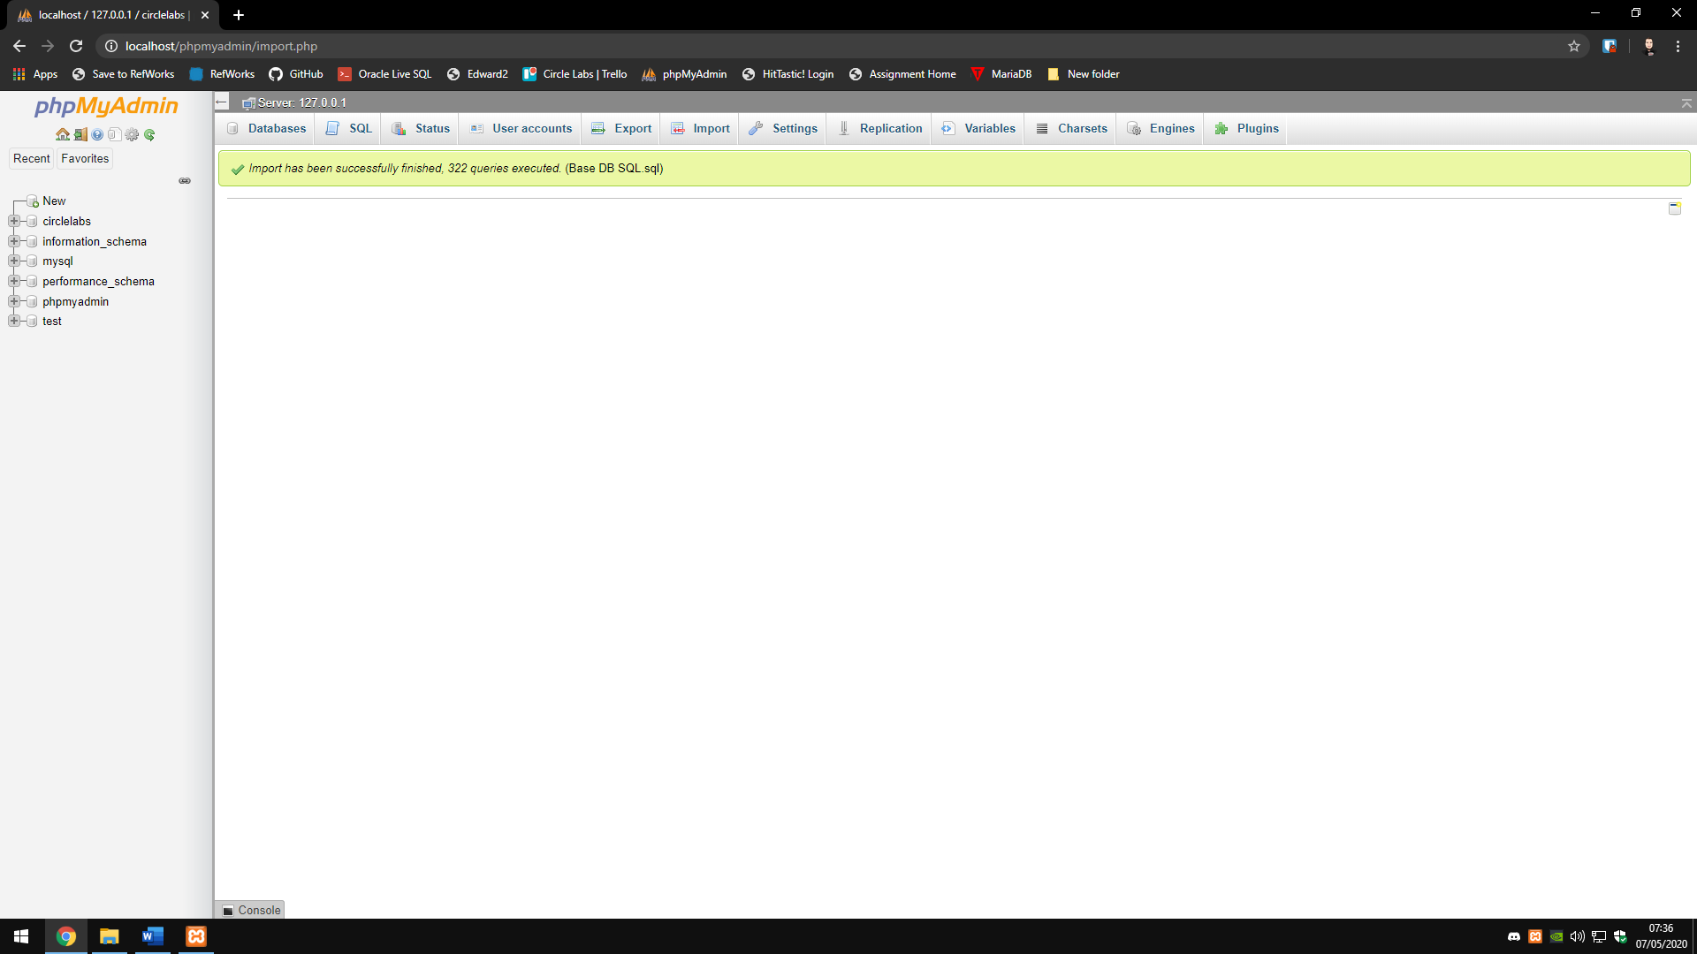

# Setting up the site

1. Copy the smms folder to C:\xampp\htdocs
2. Then using your web browser go to this address <http://localhost/smms/>